Land scaping

## Land Leveller Rear

**Category:** Land Developing Implement

**Tag:** Tractor Mounted Land Leveller Rear

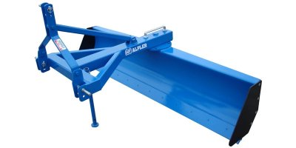

## Description

* It is used for clearing fields, land levelling, opening ditches and fillings
* It is easily mountable with three point linkage
* The special steel blade prevents the corrosion and breaking
* It can be used for pulling as well as pushing the soil
* It can be used for back filling

|  |  |  |  |
| --- | --- | --- | --- |
| Specifications | | | |
|  | 8FT | 9FT | 10FT |
| Linkage | Three points | | |
| Width | 96’’ | 108’’ | 120’’ |
| Length | 36’’ | 36’’ | 36’’ |
| Height | 44’’ | 44’’ | 44’’ |
| Weight | 225 KG | 240 KG | 255 KG |
| Tractor Compatibility | 50 HP | 65 HP | 1. HP |

## Laser Land Leveller

**Category:** Land Developing Implement

**Tag:** Tractor Mounted Laser Land Leveller

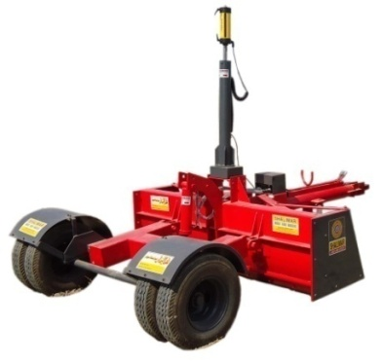

## Description

High precision tractor mounted laser land leveller for irrigated or sloped lands.

Used in combination with sensors on scrapper to bring land to near flatness or with slight gradient (as per requirement)

1. Hassle-free, reliable, effective & easy to operate power mast which saves both time & energy
2. More levelled and smooth soil surface obtained
3. More uniform moisture environment for crops. Reduced consumption of seeds, fertilizers, chemical and fuel
4. Improved crop establishment by uniform spreading of water, seeds, fertilizers & chemicals
5. Decreases the time to complete tasks of irrigation
6. Improves uniformity of crop maturity
7. Reduces weed problems
8. Reduces the amount of water required for land preparation

**Includes:**  
Laser Transmitter  
Receiver

Control Box  
Hydraulic Assembly   
Wires & Pipes  
Hydraulic Operated Scrapper

Tripod & Power Mast

|  |  |  |
| --- | --- | --- |
| Specifications | | |
|  | 8FT | 10FT |
| Scraping Blade | 6'' x 16 MM | |
| Width | 96’’ | 120’’ |
| Length | 164’’ | 164’’ |
| Height | 24'' | |
| Weight | 900 KG | 1000 KG |
| Tyre size | 6-50-14 (Double) | |
| Tractor Compatibility | 75 -85 HP | 85 HP |

## Hydraulic Scraper

**Category:** Land Developing Implement

**Tag:** Tractor Mounted Land Developing Implement

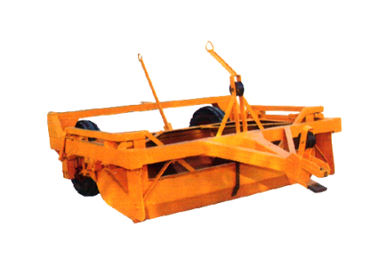

## Description

Scraper is a large piece of heavy equipment used for earth moving purposes. The front of the Scraper cuts into the earth, while storing the excess material in a rear mounted hopper. The unit's cutter can typically be hydraulically raised and lowered to cut at specific depths.

|  |  |  |
| --- | --- | --- |
| Specifications | | |
|  | Manual | Hydraulic |
| Scraping Blade | 5'' x 90'' | |
| Width | 104’’ | |
| Length | 144’’ | |
| Height | 36’’ | |
| Bucket sheet | 12 MM | |
| Bearing Hubs | 2 | |
| Tyre size | 600 - 16 | |
| Tractor Compatibility | 75 -85 HP | 85 HP |

## Posthole Digger

**Category:** Land Developing Implement

**Tag:** Tractor Mounted Land Developing Implement

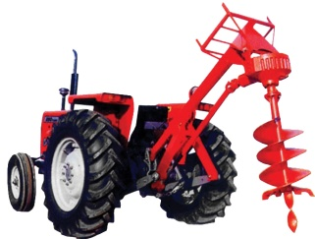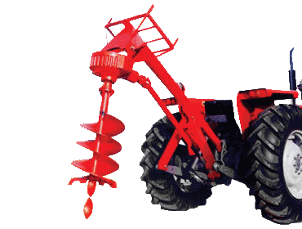

## Description

* As it is a PTO driven Implement, it is fastest method to dig holes in farm land
* It can dig holes up to 6", 9", 12" or 18" diameter
* It has special steel cutting tip with semi-double flighting, which handles tough conditions
* It has heavy duty gear box & PTO shaft with slip clutch for overload protection
* Shocker assembly to control oscillating
* It can make hole up to 35" deep with even diameter in 30 seconds
* Digs holes in rows on equal distances. Mechanically and economically
* Best for tree plantation, electrical poles and farm hedges

|  |  |
| --- | --- |
| Specifications | |
| Time required for one hole | 30 Seconds |
| Auger Blades | Replaceable |
| Auger Blade Sheet | 6 MM |
| PTO | 540 RPM |
| Hole Depth | 36'' |
| Tractor Compatibility | 50-60 HP |

## Front blade

**Category:** Land Developing Implement

**Tag:** Tractor Mounted Land Developing Implement

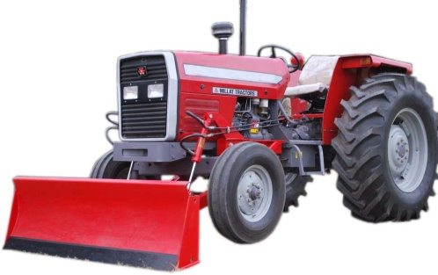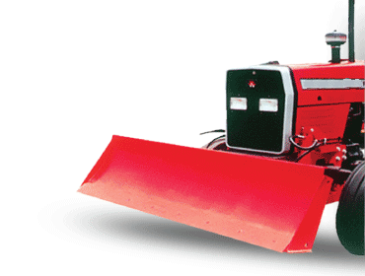

## Description

## Front Blade is being attached with Tractor front. Usually, it is used to remove objects & materials from the ground like soil, stones & rocks. This blade can be used in agricultural lands, construction sites & infrastructure development sites.

* Hydraulic operated front blade
* Twin hydraulic cylinders – mounted on sub-frame of tractor
* Quick attachment/detachment
* Strong Mouldboard – reinforced on bank, sides and bottom.
* Reversible/replaceable cutting edge
* Suitable for heavy duty construction
* Imported spool valve
* Rigid steel piping (hydraulic cylinder)

|  |  |
| --- | --- |
| Specifications | |
| Blade Size | 66'' - 96'' |
| Depth below ground | 4'' |
| Max lift | 21'' |
| Scraping Blade | 6'' x 12.7 MM |
| Blade Pitch | 0 - 40 degree |
| Tractor Compatibility | 50 HP |